Arrays – Linear Algebra

# Part I

You do not need to turn anything in for this part of the assignment (but it is in your best interest not to skip this as you will find out in part II)

Fill in the table of built in MATLAB functions for analyzing arrays. Use google or the MATLAB help to find them all.

|  |  |  |
| --- | --- | --- |
| **Function** | **Description** | **Example of how to use** |
| det(A) |  |  |
| dot(A,B) |  |  |
| cross(A,B) |  |  |
| inv(A) |  |  |

# Part II

# Instructions

Complete the array practice problems below by having MATLAB compute them sequentially from a .m file. In order to get full credit, **you must use ; to suppress the values of everything but the answer from the command window**. Complete the assignment by posting a single .m file named appropriately to the D2L folder. See syllabus if you are not sure how to name .m file.

Most of the variable names should be given in the problem. If not, name them something that makes sense. Please make sure that you are commenting appropriately and that you are following the problem instructions.

# Problems

1. 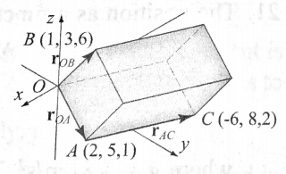The volume of the parallelepiped shown can be calculated by ${\overset{⃑}{r}}_{OB}∙({\overset{⃑}{r}}_{OA}×{\overset{⃑}{r}}_{AC})$. Use the following steps in a script file to calculate the volume. Define the vectors ${\overset{⃑}{r}}_{OA}$, ${\overset{⃑}{r}}_{AC}$, and ${\overset{⃑}{r}}_{OB}$ from knowing the position of points *A*, *B*, and *C (be careful you read this carefully!).* Determine the volume by using MATLAB built-in functions dot and cross.
2. Solve the following system of linear equations: $$2.5a-b+3c+1.5d-2e=57.1 \\ 3a+4b-2c+2.5d-e=27.6 \\ -4a+3b+c-6d+2e=-81.2 \\ 2a+3b+c-2.5d+4e=-22.2 \\ a+2b+5c-3d+4e=-12.2$$

# Background

Kirchhoff’s voltage law states that the sum of the voltage around a closed circuit is zero. In the mesh current method a current is first assigned for each mesh $(i_{1},i_{2},i_{3},i_{4}$ in the figure). Then Kirchoff’s voltage law is applied to each mesh. This results in a system of linear equations for the currents (in this case four equations). The solution gives the values of the mesh currents. The current in a resistor that belongs to two meshes is the sum of the currents in the corresponding meshes. It is convenient to assume that all the currents are in the same directions (clockwise in this case). In the equation for each mesh, the voltage source is positive if the current flows to the – pole, and the voltage of a resistor is negative for current in the direction of the mesh current.

1. The electrical circuit shown consists of resistors and voltage sources. Determine the current in each mesh using the mesh current method, which is based on Kirchhoff’s voltage law. $V_{1}=20 V$ 
     
   , $V_{2}=12 V$, $V_{3}=40 V$ $R_{1}=18Ω$ 
   , $R_{2}=10Ω$, $R_{3}=16Ω$, $R_{4}=6Ω$, $R_{5}=15Ω$, $R_{6}=8Ω$, $R_{7}=12Ω$, $R_{8}=14Ω$  
     
   The equations for the four meshes in the current problem are: $$V_{1}-R_{1}i_{1}-R_{3}\left(i_{1}-i_{3}\right)-R_{2}\left(i_{1}-i_{2}\right)=0 \\ -R_{5}i_{2}-R_{2}\left(i_{2}-i_{1}\right)-R_{4}\left(i_{2}-i_{3}\right)-R_{7}\left(i_{2}-i_{4}\right)=0 \\ -V_{2}-R_{6}\left(i_{3}-i_{4}\right)-R_{4}\left(i_{3}-i_{2}\right)-R_{3}\left(i_{3}-i_{1}\right)=0 \\ V_{3}-R_{8}i_{4}-R_{7}\left(i_{4}-i_{2}\right)-R_{6}\left(i_{4}-i_{3}\right)=0$$ 
     
   **HINT**: setup the linear algebra equation in the form $\left[A\right]\left[x\right]=\left[B\right]$. You may have to rearrange the equations above.

***EXTRA CREDIT:   
Worth 4 HW Points (that’s like 1/3 of an assignment!)***

Determine $(i_{1},i_{2},i_{3},i_{4},and i_{5})$ using the mesh method based on Kirchhoff’s voltage law for the circuit shown.

Given:

$V_{1}=40 V$, $V_{2}=30 V$, $V_{3}=36 V$ $R_{1}=16Ω$ 
, $R_{2}=20Ω$, $R_{3}=10Ω$, $R_{4}=14Ω$, $R_{5}=8Ω$, $R_{6}=16Ω$, $R_{7}=10Ω$, $R_{8}=15Ω$, $R_{9}=6 Ω$, $R_{10}=4Ω$

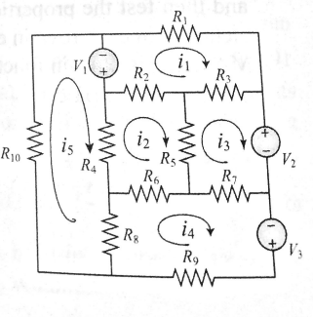

I guess it is time for you to make a BioE friend!